Facts on Neighbourhood Policing Teams

Neighbourhood Policing is about putting the community at the heart of everything we do. It's about local people being a part of the solution to local issues that concern them.
Neighbourhood Policing Teams are dedicated to solving issues in the local community. They work closely with partner agencies, such as local authorities and housing associations, and local people to identify issues that need to be improved in their neighbourhood.

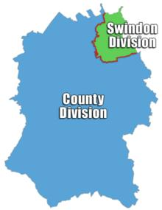
Contact your Neighbourhood Policing Team: to find out contact details for your Neighbourhood Policing Team (NPT).

Go to the Wiltshire Police website www.wiltshire.police.uk and click on the “Policing in your Area” button

